**Practical 2 : a) Write a shell script with basic commands like echo and read**

**b) Write a shell script to display addition of given two numbers**

**a)**

echo "enter you name "

read name

echo "hello $name welcome to shell script"

Output :

enter you name

harsh

hello harsh welcome to shell script

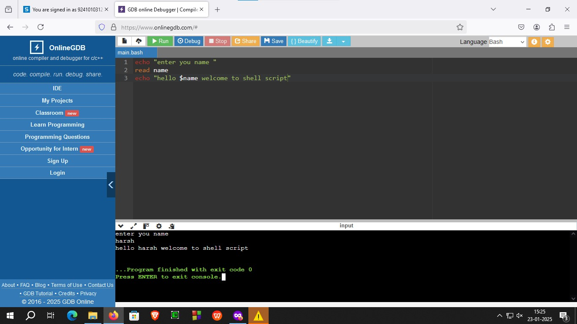

**Figure 2.1 : printing in bash**

b)

echo "my name is harsh vadgama"

echo "my enrollment number is 92410103123"

echo "my class is EC5-C"

echo "enter number 1 : "

read no1

echo "enter number 2 : "

read no2

sum=$((no1+no2))

echo "result: $sum"

Output:

my enrollment number is 92410103123

my class is EC5-C

enter number 1 :

12

enter number 2 :

12

result: 24

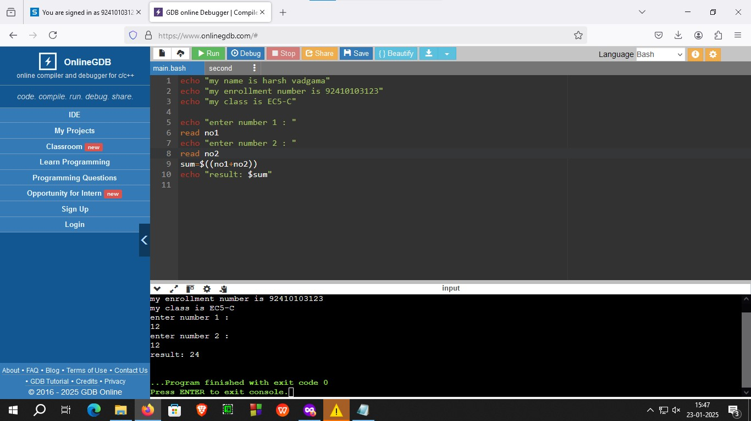

Figure 2.2 : adding two numbers